**بسم الله الرحمن الرحيم**

God willing, all the observations will be listed with some consideration if the observations are formative or observations are essential because the main objective is to reach the best possible form, so that some of them are not forgotten

God willing, screenshots of other programs such as (Peachtree , Quickbooks and oracle to make the idea clear and

1. we should have one menu item name SETUP:

Contains the main forms like (Company info form, School info form, Countries and cities .. etc)

**Example:**

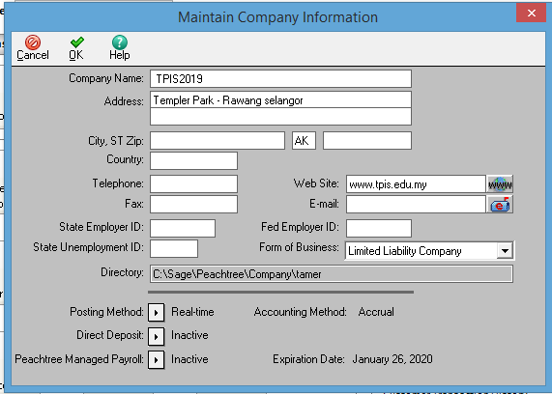

1. it is a must to have only one currency in the whole of the application and disable the ability of change currency in all forms which deal with money
2. It is preferable to have the flexibility of the end user to locate the logo in reports or pdf of the school or company either on the right or on the left or in the middle and so on.
3. for the HR module

There are only two factors in which accounting software versions differ from one country to another

A. Employee benefits and deductions (HR)

B) The tax regulations applicable to the company

For example, there are a number of different deductions here in Malaysia applied to employees not found in other countries such as (EPF, SOCCO and EIS) and therefore the strong reasons that enable the program to compete it is in line with the existing systems in the country

So if we hope to compete CAMPUS ERP in different countries (Gulf countries and East Asia) or at least now Saudi Arabia and Malaysia must be in line with its system

 So I agreed with Majal in the presence of the icon for the initial configuration Payroll Set up within the general map of Employees.

**Example:**

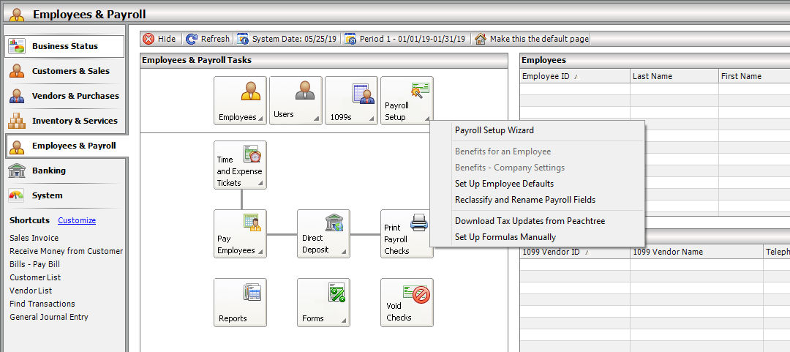

**7- Accounting Module**

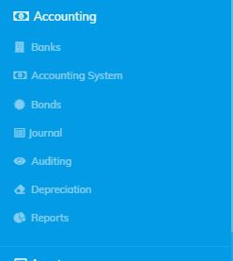

7-1 BANKS

The four forms which exists in the Banks menu should place in one form

**Example:**

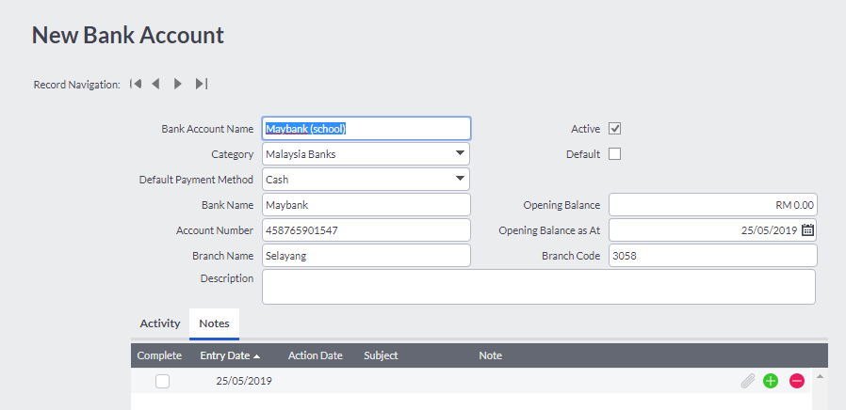

Note that once the page is saved ... an account is created (in the name of the bank and branch) in the accounts directory followed by the current assets (hence it is linked to the account tree and then we can treat it as an independent account)

**7-2 Accounting system**

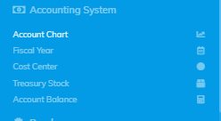

**1- ِAccount chart**

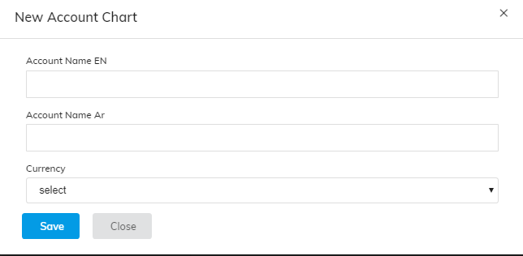

* Add details field here
* Add account balance here. *
* Remove currency field.
* Off-course we will not have option of change currency no more.

B - Difficulty registering a new account compared to other programs (where it is required to open all branches of the tree to register a sub-account in the fifth level

These steps can be provided in the following figure as explained in the previous discussion

We can add the option of new account in the page with quick box to show the third level which we will make it as static, then when choose it will created in the fourth level automatic under the third level which the user choosed from the quick box

Example

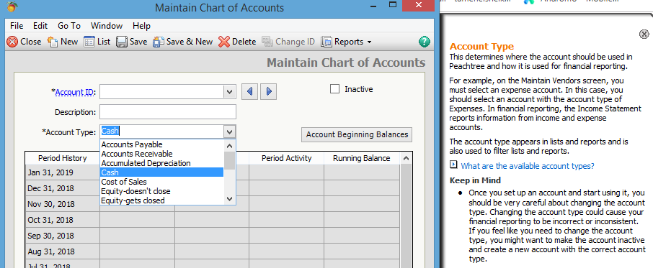

* In the accounts chart page grid (it is a must) the gris show the balance for the account.

EXAMPLE

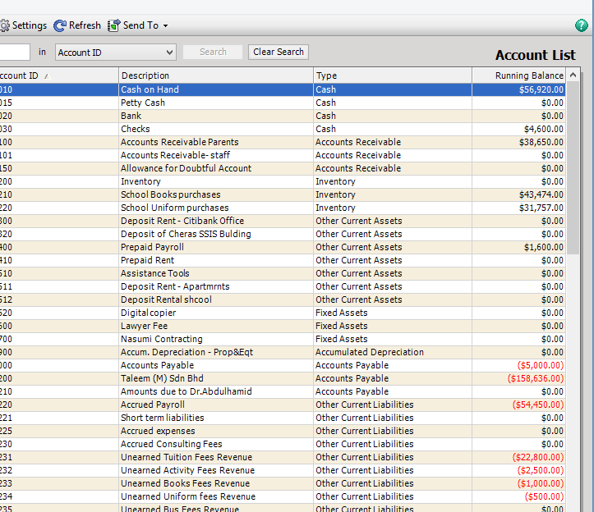

2. Fiscal Year shall be transferred to the system settings section in the company page (and will affect in all schools registered on the company ) referred to in the first set of observations and may be guided as follows

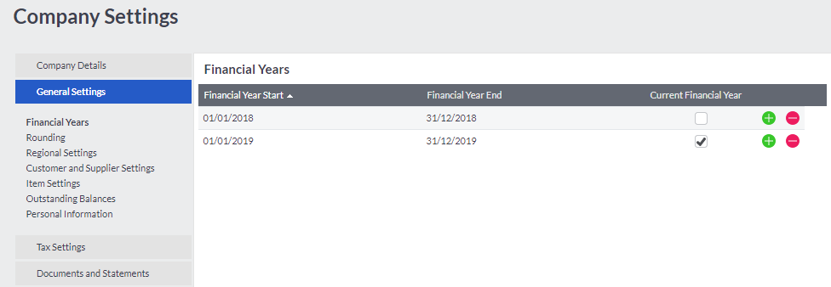

3- Cost Center

Are well recorded (data only so far) need more work to build and extract models and reports on the status of each center whether profit, loss, importance, content etc. and show balance in the grid which show the cost centers.

**4-Treasury Stock**

Translation of the word into English is inaccurate

If the intended stock types are present in the company, this is added with the account data in the accounts chart because it must be linked to the accounts chart and therefore proposed to cancel this icon and form from here.

**5. Account Balance**

  This is not the right place for this. It is should be within the accounts chart o

When add new account in the chart. (* discussed in point 1 )

**7-3 Bonds**

Contains 6 sub-icons related to payments, cash receipts, checks issued and issued, arrest papers and payment papers. 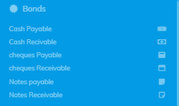

These were used in the past when designing programs (called bonds)

The best is to distribute each icon to its proper place. For example, the icon of the cash receipts in student’s module, as indicated by

The icon for cash payments is placed in the Suppliers module as indicated by

Checks received and issued in BANKS are also marked as indicated above

If it is proposed to delete this part and that its contents have been distributed elsewhere.

**7-4 journal**



The journal parts should be automatic not only 6 as it is

They apply good one here, we need like it in journals

The shown should be 6 and if go the row 6 he will find 7 row and like that.

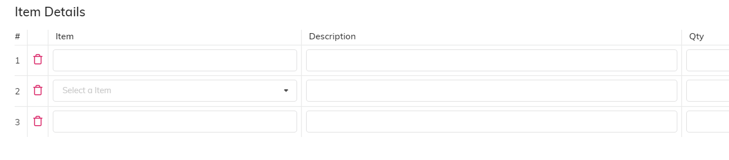

**Auditing 7-5**



**Auditing change name to Reports**

Ledger

Note to the exists is show the account of for one account only ......

It's best to show a professor account for all or select some accounts

As this is frequently requested by the financial management or the external auditor.

And also notes that the way the presentation and design of the form is similar to the design used Dvtria and not what is presented by electronic programs ... ... so I propose to redesign **again**

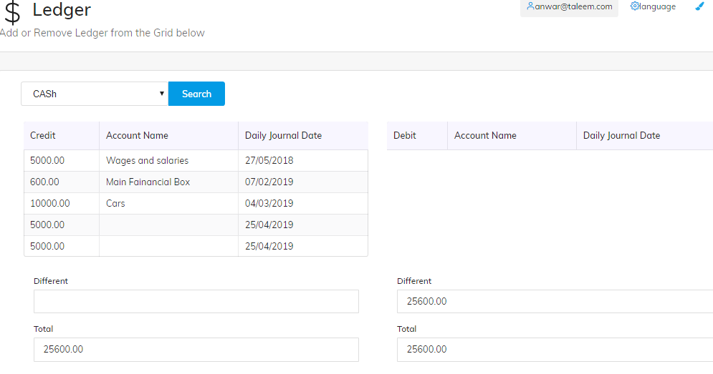

**ب- Trial Balance**

**Should work fine. It is not active**

**ج- Income Statement**

**Should work fine. It is not active**

**د- Balance sheet**

**Should work fine. It is not active**

# **Depreciation 7-5**

**Should work fine. It is not active**

**I will send reports examples for:**

**Ledger – Trial Balance - Income Statement- Balance sheet**